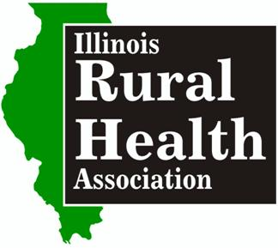

Nomination Form 2016 - Rural Physician of Excellence Award

The IRHA is accepting nominations for the 2016 Rural Physician of Excellence Award. The award presentation ceremony will take place in the winner’s community with invited media, elected officials, colleagues, family and friends in the fall 2016.

Please complete the nomination form below and attach: 1) an overview of the nominee’s professional/educational background (can include CV) and community service; 2) a description of the impact of the individual has made on the health and wellbeing of the community by going above and beyond their mission of improving the quality and access to care in rural medically underserved areas of the state (include examples); and 3) one additional letter of recommendation from someone (separate from the nominator)familiar with the physician’s work, explaining why the physician would make a good choice for the award. The nomination must be submitted by an IRHA member (only one nomination per member) but any physician practicing in Illinois is eligible to be nominated.

Nomination Deadline Monday August 1, 2016 Nominations can be submitted via mail, email or fax to:
Margaret Vaughn, IRHA Executive Director
9211 Waterfall Glen Blvd.
Darien, IL 60561
Phone: 217-280-0206
Fax: 630-908-7311
Staff@ilruralhealth.org

Physician Nominee:
Organization and title (if applicable)

Address:

Email/Phone:

IRHA Nominator:

Organization and title (if applicable):

Address:

Email/Phone:

