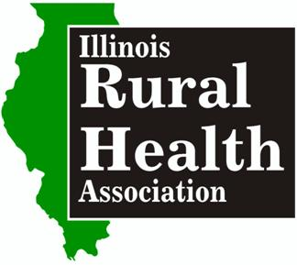
Attention Health Informatics/HIT Students … Scholarship Opportunity

The Illinois Rural Health Association recognizes the growing demand for health informatics specialists in rural areas. The Illinois Rural Health Association is sponsoring five $1000 Medical Billing & Coding Scholarships for the spring semester 2017.

Criteria – Students currently enrolled in a Medical Informatics or HIT program, with an intent of working in a rural health and who otherwise not have for their full tuition reimbursed through an employer or grants, etc.

Please contact IRHA Executive Director Margaret Vaughn 217-280-0206 with questions staff@ilruralhealth.org . Visit us online at www.ilruralhealth.org

Application process:

- Fill in the form below.
- In 400 words or less, explain your interest in rural health, future career goals and why you would make a good choice to receive the scholarship. Please type your essay as an additional page on the bottom of this document. Do not email multiple attachments.
- Email completed application with essay to staff@ilruralhealth.org by Nov. 25th, 2016

Student Applicant Name:
Program of Study: Graduation Date:
County of Residence:
Educational Institute: GPA:
Email: Phone:
Degrees or Certificates (include school and year):

Current Employer:
Job Title/Duties:

Professional/Academic Reference: (Name, title, email and phone).

