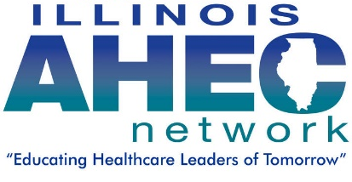
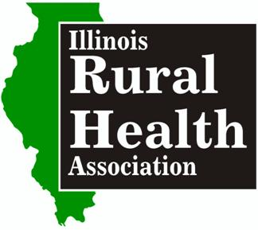
Attention Medical Billing & Coding Students … Scholarship Application

The Illinois Rural Health Association, recognizes the great demand for trained medical coding and billing experts in rural areas. The Illinois Rural Health Association is working with IL AHEC (Area Health Education Centers), to sponsor a limited number of $1000 Medical Billing & Coding Scholarships for the spring semester 2017.

Criteria – Students currently enrolled in a Medical Billing and Coding program, have an interest in service to rural health and who otherwise not have for their tuition reimbursed through an employer.

Please contact IRHA Executive Director Margaret Vaughn 217-280-0206 with questions staff@ilruralhealth.org . Visit us online at www.ilruralhealth.org

Application process:

- Please find your county of residence on the next page and email your application to the AHEC contact for that region by Nov. 25, 2016,
- In 300 words or less, explain your interest in rural health, future career goals and why you would make a good choice to receive the scholarship. Please type your essay as an additional page on the bottom of this document. Do not email multiple attachments.

Application Form

Student Applicant Name:
Program of Study: Graduation Date:
County of Residence:
Educational Institute: GPA:
AHEC Region: (see attached list)
Email: Phone:
Current Employer:
Job Title/Duties:

Find your county and email your Scholarship application to the appropriate AHEC contact by November 25, 2016

- NORTHWEST AHEC: Covers Boone, Bureau, Carroll, DeKalb, Henry, Jo Daviess, LaSalle, Lee, Mercer, Ogle, Rock Island, Stephenson, Whiteside and Winnebago Counties. Submit to Melissa Rockwood mrockwood@ksbhospital.com

- CENTRAL AHEC : Covers DeWitt, Logan, Macon, Marshall, McLean, Menard, Moultrie, Peoria, Piatt, Putnam, Sangamon, Stark, Tazewell and Woodford counties. Submit to Sharon Mills at smmills@ilstu.edu

- EAST CENTRAL AHEC: Covers Kankakee, Livingston, Ford, Iroquois, Champaign, Vermillion, Douglas, Edgar, Coles, Cumberland, and Clark Counties. Submit to Eileen Woolums Eileen Woolums eileen_woolums@gibsonhospital.org

- SOUTH CENTRAL AHEC: Covers Bond, Clay, Clinton, Crawford, Christian, Effingham, Fayette, Jasper, Jefferson, Lawrence, Madison, Marion, Monroe, Montgomery, Richland, Shelby, St. Clair, and Washington Counties. Submit to Kelli Stover Kelli_Stover@ssmhc.com

- SOUTH EAST AHEC : Covers Alexander, Edwards, Franklin, Gallatin, Hamilton, Hardin, Jackson, Johnson, Massac, Perry, Pope, Pulaski, Randolph, Saline, Union, Wabash, Wayne, White and Williamson Counties. Submit to Beth Wilson- bethrnsane@yahoo.com

- WEST CENTRAL AHEC: Covers Adams, Brown, Calhoun, Cass, Fulton, Green, Hancock, Henderson, Jersey, Knox, Macoupin, Masson, McDonough, Morgan, Pike Schuyler, Scott, Warren. Submit to Jennifer Talbert – jennifer.d.talbert@osfhealthcare.org

Can’t find your county listed? Please submit application to staff@ilruralhealth.org 217-280-0206

